NORTHEASTERN UNIVERSITY

STUDENT – Dev Bhadreshkumar Panchal
Module 12 Project
CLASS NUMBER - ALY 6080
CLASS – Integrated Experiential Learning
CRN NUMBER – 70242
INSTRUCTOR – Valerie A. Atherley
ACADEMIC YEAR – FALL 2025
COMPLETION DATE – 4th December, 2025
EMAIL – panchal.devb@northeastern.edu

Individual Project Proposal

A. Statement of Purpose

Background of the Project
Your Sweet Spot Life (YSSL) operates a collaborative joint venture model supporting Canadian creative professionals across arts, media, film, music, and design through their Creative ERP/CRM platform. While YSSL has established effective frameworks for project development and intellectual property management, the organization currently lacks systematic insights into the specific trademark registration challenges their creative partners face when protecting brand identities and creative works.
Canadian creative professionals encounter substantial barriers in securing trademark protection. Research demonstrates that small creative enterprises often lack access to affordable legal tools and face disproportionate challenges navigating complex intellectual property systems (WIPO, 2023). Unlike established corporations with dedicated legal departments, independent artists, small studios, and emerging creative businesses struggle with understanding filing requirements, anticipating approval timelines, and avoiding common application errors that lead to abandonment or rejection.
The Canadian Intellectual Property Office (CIPO) processes hundreds of thousands of trademark applications across all industries, yet systematic analysis of creative sector-specific patterns remains limited. Understanding where creative professionals experience the highest failure rates, longest processing delays, and most frequent abandonment enables YSSL to design targeted compliance support features within their platform. Furthermore, quantifying these barriers provides evidence-based justification for YSSL's mission and validates the need for accessible IP management tools tailored to creative industries.

Business Questions to be Addressed
What is the overall success rate of trademark applications in Canada's creative industries compared to general business applications?
How does processing time differ between creative sector trademarks and non-creative applications?
Which creative industry subsectors (film, music, design, digital arts) experience the highest failure and abandonment rates?
What trademark characteristics (word marks vs. figurative marks, language choice, mark classification) correlate with registration success in creative industries?
Can machine learning models predict trademark registration outcomes for creative professionals, enabling proactive application optimization?

Goals and Objectives
The primary goal is to analyze the Canada Trademarks Dataset to quantify intellectual property registration barriers facing Canadian creative professionals and develop predictive models informing YSSL's platform design. Specific objectives include:
Barrier Quantification: Calculate success rates, failure rates, and abandonment rates for creative industry trademark applications compared to baseline business applications, identifying the magnitude of challenges creative professionals face.
Timeline Analysis: Measure average time-to-approval, time-to-abandonment, and processing delays for creative sector applications, establishing realistic expectations YSSL can communicate to platform users.
Sector-Specific Insights: Disaggregate creative industries into film/video, music, design, and digital arts subsectors, determining which face greatest registration challenges and should receive prioritized platform support.
Predictive Modeling: Develop machine learning classification models predicting trademark registration success based on application characteristics, enabling YSSL to provide proactive guidance identifying high-risk applications before submission.
Platform Recommendations: Translate analytical findings into specific feature recommendations for YSSL's Creative ERP/CRM platform, ensuring compliance tools address empirically validated pain points.

Organizational Benefits
Implementation provides YSSL with substantial strategic advantages:
Evidence-Based Platform Design: Data-driven insights identifying which compliance assistance features provide maximum value to creative professionals, enabling efficient resource allocation during platform development.
Targeted User Segmentation: Understanding which creative subsectors face greatest IP challenges allows YSSL to tailor messaging, support materials, and platform functionality to highest-need user groups.
Competitive Differentiation: Systematic analysis of creative industry IP barriers positions YSSL as the only platform with empirically validated understanding of creative professionals' trademark challenges, enhancing credibility with partners and funders.
Proactive Risk Mitigation: Predictive models enable YSSL to warn users about high-risk application characteristics before filing, potentially preventing costly abandonment and resubmission cycles.
Scalability Intelligence: Geographic and temporal analysis revealing how trademark registration challenges vary across provinces informs YSSL's expansion strategy beyond their current Saint John, New Brunswick base.

B. Scope of the Project

Scope of Work
This analytical project encompasses four integrated work streams:
Data Preparation and Cleaning: Extract and process Canada Trademarks Dataset (Sheff, 2023) containing 1.9+ million trademark applications from 1865-2023. Develop classification algorithms identifying creative industry applications through keyword analysis of owner names, trademark descriptions, and goods/services classifications. Handle missing values, inconsistent date formats, and data quality issues inherent in historical administrative datasets.
Descriptive Analytics: Calculate fundamental success metrics including registration rates, abandonment rates, and expungement patterns across creative industries. Perform temporal analysis examining how registration success has evolved from 2000-2023. Conduct comparative analysis measuring creative industry outcomes against general business baseline. Generate geographic insights if provincial data available.
Predictive Modeling: Develop machine learning classification models predicting trademark registration outcomes (Registered vs. Abandoned vs. Expunged) based on application characteristics including mark type, language, classification codes, and temporal variables. Implement Random Forest, XGBoost, and Logistic Regression algorithms with cross-validation. Feature engineering creating variables like mark complexity, application completeness proxies, and temporal risk factors.
Insight Translation: Synthesize analytical findings into actionable platform design recommendations for YSSL. Identify which trademark characteristics predict failure in creative industries, informing automated validation checks YSSL's platform should implement. Quantify processing timelines enabling realistic expectation-setting for YSSL's users.

Key Deliverables
Primary Sponsor Deliverable:
Comprehensive analytical report documenting creative industry trademark registration barriers with sector-specific success rates, processing timelines, failure pattern analysis, and strategic platform recommendations tailored to YSSL's Creative ERP/CRM development priorities.
Academic Program Deliverables:
Predictive model specifications with validation results demonstrating 75%+ accuracy in forecasting trademark registration outcomes based on application characteristics. Data visualizations including temporal trend charts, geographic comparison maps, success rate distributions, and creative industry performance dashboards. Python analysis scripts with full documentation enabling reproducibility and demonstrating technical proficiency across data manipulation, statistical analysis, machine learning, and visualization domains.
The scope is completable within the 6-month academic timeline, requiring approximately 8-10 weeks for data preparation and exploratory analysis, 6-8 weeks for predictive modeling development and validation, and 4-6 weeks for insight synthesis and documentation.

C. Background Research and Literature

Literature Review
Predictive Analytics in Creative Professional Success
Ucar et al. (2022) demonstrated that machine learning algorithms effectively predict professional success in creative industries by analyzing multi-dimensional data including productivity metrics, collaboration networks, and audience engagement patterns. Their XGBoost regression models achieved 82% accuracy predicting genre-specific success outcomes for musicians using Spotify and Musicbrainz data. The research identified four critical predictors: average popularity scores, productivity metrics (release frequency and consistency), collaboration network strength, and genre classification patterns.
These methodological insights directly inform the current project's predictive modeling approach for trademark registration outcomes. Just as Ucar et al. found that multi-dimensional analysis combining artistic output, audience engagement, and strategic networking behaviors enabled accurate success forecasting, analyzing trademark applications requires examining multiple characteristics simultaneously—mark type, classification codes, language selection, and temporal patterns. The research validates using ensemble methods like Random Forest and XGBoost for creative industry predictions, as these algorithms handle mixed data types and non-linear relationships effectively while providing interpretable feature importance rankings essential for translating findings into actionable platform recommendations for YSSL.
Evaluation Frameworks for Creative Organizations
Swan and Atkinson (2012) examined how community arts organizations balance creative ethos with external evaluation demands from funders and stakeholders through year-long ethnographic study involving twenty semi-structured interviews with arts organization staff and participants. Key findings revealed that while staff recognized evaluation as necessary for accountability and funding, they viewed quantitative metrics as potentially threatening to organizational values when imposed without creative professional input.
The research identified three primary challenges directly relevant to analyzing trademark data for YSSL: satisfying multiple stakeholders with competing priorities, measuring indirect outcomes beyond simple success/failure metrics, and capturing systemic patterns without reducing creative work to reductive categorizations. Swan and Atkinson's framework for negotiated evaluation emphasizes developing alternative evidence methods including both quantitative metrics and qualitative context. For the current project, this translates to ensuring trademark success rate calculations and failure pattern identification illuminate systemic barriers within Canada's IP registration system rather than suggesting individual creative professional shortcomings. The research reinforces that YSSL's platform must present IP compliance data transparently while respecting creative professionals' agency, avoiding surveillance-oriented framing in favor of empowerment-focused insights.
Dashboard Design for Actionable Analytics
Susnjak et al. (2022) systematically reviewed 17 learning analytics dashboards, revealing most employ only descriptive analytics without predictive or prescriptive capabilities, significantly limiting effectiveness. They propose comprehensive frameworks integrating descriptive (current status), predictive (trajectory forecasting), and prescriptive (personalized recommendations) analytics with explainable AI features. Their research identifies five critical challenges: data complexity management, ensuring actionable insights, privacy ethics, technological agility, and information overload prevention.
Specific design guidance includes limiting color schemes to 4-6 colors for visual clarity, prioritizing mobile-responsive layouts, and incorporating customization options—evidence-based principles directly applicable to visualizing trademark analysis results for YSSL. The framework's emphasis on translating complex data into clear decision-support tools informs how this project should present findings. Rather than overwhelming YSSL with statistical minutiae, deliverables must distill trademark patterns into specific platform feature recommendations. For example, if analysis reveals Word marks in certain classifications experience 30% higher success rates than Figurative marks, YSSL's platform should proactively alert users considering logo-based trademarks about elevated risk and suggest alternative strategies. Susnjak et al.'s research validates combining multiple analytics levels—descriptive metrics establishing baseline creative industry performance, predictive models forecasting individual application outcomes, and prescriptive recommendations guiding YSSL's platform design priorities.
Similar Successful Research
Sheff's (2021) analysis of the Canada Trademarks Dataset generated novel descriptive insights into registration system performance and applicant behavior through individual-application-level analysis of 1.6+ million records. His research demonstrated that Canada's trademark registration system substantially underperforms other nations regarding examination efficiency, with recent statutory changes potentially exacerbating delays while decreasing registry reliability. Sheff's methodological approach—combining large-scale quantitative analysis with institutional context—provides the blueprint for the current project's analytical framework. His findings that registration timelines and success rates vary significantly across application characteristics validate examining creative industry applications as distinct population requiring tailored analysis rather than assuming uniform system performance across all applicant types.

D. Design and Data Collection Methods

Data Sources and Collection Strategy
The project utilizes the Canada Trademarks Dataset (Version 2.0) compiled by Sheff (2023), representing the Canadian Intellectual Property Office's comprehensive historical archive of trademark applications. This individual-application-level dataset includes records of all applications since approximately 1980 and many preserved applications dating to Canada's trademark registry inception in 1865, totaling 1.9+ million application records. The dataset is publicly available through Zenodo (https://doi.org/10.5281/zenodo.4999655) under CC-BY-4.0 license with additional CIPO terms.
Dataset Characteristics:
Comprehensive bibliographic and lifecycle data including application numbers, registration numbers, current status classifications, and complete date histories (application, publication, allowance, registration, abandonment, expungement, renewal, termination). Trademark characteristics encompassing mark text, detailed descriptions, mark type classifications (Word, Figurative, Combined), standard character indicators, and mark class codes differentiating general trademarks from specific marks. Goods and services claims with classification codes enabling industry categorization. Applicant identification including owner names, attorney information, and other interested party details. Detailed prosecution history capturing all administrative actions throughout application lifecycle. The dataset's individual-application granularity enables precise filtering for creative industry analysis while comprehensive temporal coverage (140+ years) supports robust trend identification.
Creative Industry Identification Strategy:
Develop multi-layered filtering algorithm identifying creative industry applications through keyword analysis and classification code examination. Primary identification searches owner names for keywords including: film, video, production, studio, music, musician, composer, artist, gallery, design, designer, creative, media, entertainment, broadcasting, publishing, theater, dance, photography, digital arts. Secondary identification examines trademark text and descriptions for creative goods/services terminology. Tertiary validation uses goods/services classification codes corresponding to creative industries (Class 041 Education and Entertainment, Class 035 Advertising and Business services, portions of Class 009 covering digital creative tools). Manual validation sampling ensures algorithm accuracy exceeds 90% before full-dataset application.

Analytical Methods
Descriptive Analytics:
Calculate core success metrics across identified creative industry applications including registration rate (percentage achieving Registered status), abandonment rate (percentage reaching Abandoned status before registration), expungement rate (percentage experiencing post-registration cancellation), and average lifecycle duration from application to final status. Comparative analysis measures creative industry metrics against overall dataset baseline, determining whether creative professionals experience statistically significant disadvantages. Temporal trend analysis examines how creative industry trademark success evolved from 2000-2023, identifying whether system changes improved or degraded creative sector outcomes.
Segmentation analysis disaggregates creative industries into subsectors (film/video production, music and recording, visual arts and design, digital creative services, performing arts) calculating subsector-specific success rates and processing timelines. Mark type analysis compares Word marks versus Figurative marks versus Combined marks, as creative professionals often employ logo-based branding facing potentially different evaluation standards. Language analysis examines English versus French applications, relevant given Canada's bilingual requirements potentially creating differential barriers.
Predictive Analytics:
Develop supervised machine learning classification models predicting trademark application outcomes using features derivable at application time. The target variable classifies applications into three outcomes: Registered (successful), Abandoned (failed before registration), Expunged (registered but later cancelled). Feature engineering creates variables including:
Application Characteristics: Mark type (Word/Figurative/Combined), standard character indicator, mark class code, language selection, presence of disclaimer, presence of restriction. Temporal Variables: Application year, month, day of week (capturing potential seasonality effects), time elapsed since previous application by same owner (if available). Text Complexity Metrics: Trademark text length, number of words, presence of special characters, description length. Ownership Patterns: Presence of attorney representation, corporate vs individual applicant, Canadian vs foreign ownership.
Implement three algorithm families:
Logistic Regression: Interpretable baseline model with clear coefficient interpretation enabling straightforward translation to platform recommendations. Provides probability estimates for each outcome class.
Random Forest: Ensemble method handling non-linear relationships and feature interactions effectively. Generates feature importance rankings identifying which application characteristics most strongly predict outcomes. Robust to outliers and missing data common in administrative datasets.
XGBoost (Gradient Boosting): State-of-the-art classification algorithm demonstrated effective in Ucar et al.'s creative industry research. Typically achieves highest predictive accuracy through iterative error correction.
Validation Strategy:
Split dataset temporally: training data (2000-2020), validation data (2021-2022), test data (2023) ensuring models predict future outcomes rather than merely fitting historical patterns. This temporal split prevents data leakage and validates real-world applicability. Employ 5-fold cross-validation within training period for robust hyperparameter tuning. Evaluate models using accuracy, precision, recall, F1-score for each outcome class, and ROC-AUC for discrimination ability. Emphasize recall for Abandoned class (identifying high-risk applications) as missing these represents greatest platform value loss—YSSL users benefit most from warnings about likely-to-fail applications.
Visualization and Dashboard Design:
Following Susnjak et al.'s (2022) evidence-based design principles, create intuitive visualizations translating complex patterns into actionable insights. Temporal trend line charts showing creative industry success rates over time with confidence intervals. Comparative bar charts displaying creative subsector performance against baselines. Processing timeline distributions using violin plots revealing not just averages but full outcome variability. Feature importance charts from Random Forest models showing which application characteristics most strongly predict success, directly informing YSSL's automated validation recommendations. Interactive filters enabling YSSL stakeholders to explore patterns by subsector, mark type, and time period.

E. Implementation Methodology and Strategies

Technical Architecture
Technology Stack:
Data Processing: Python with pandas for data manipulation, NumPy for numerical operations, datetime libraries for temporal calculations.
Analysis Engine: scikit-learn for machine learning models (Logistic Regression, Random Forest), XGBoost library for gradient boosting, statsmodels for statistical testing (chi-square, t-tests comparing creative vs. baseline).
Visualization: Matplotlib and seaborn for static visualizations, Plotly for interactive dashboards enabling stakeholder exploration.
Documentation: Jupyter Notebooks for reproducible analysis with integrated markdown documentation, Git for version control ensuring traceability.
Statistical Methods:
Chi-square tests of independence determining whether creative industry status significantly associates with registration outcomes. Two-sample t-tests comparing mean processing times between creative and non-creative applications. Survival analysis using Kaplan-Meier estimators examining time-to-event distributions for registration and abandonment, accounting for right-censored observations (applications still pending). Confidence interval construction for all rate estimates ensuring statistical rigor beyond point estimates.
For predictive modeling, employ stratified sampling maintaining outcome class proportions across train/validation/test splits given class imbalance (registered applications likely outnumber abandoned). Implement SMOTE (Synthetic Minority Over-sampling Technique) if class imbalance severe, though carefully validating synthetic samples don't distort creative industry patterns. Hyperparameter tuning using GridSearchCV or RandomizedSearchCV optimizing for F1-score balancing precision and recall.

Validation and Testing
Model Validation:
Temporal cross-validation with training data (2000-2020), validation data (2021-2022), and holdout test data (2023) simulating real-world deployment where models trained on historical data predict future application outcomes. Compare model performance against naive baseline (predicting majority class) and informed baseline (predicting based on historical creative industry success rate) ensuring machine learning provides genuine improvement. Analyze confusion matrices identifying which outcome classes models predict most accurately and where errors concentrate.
Robustness Checks:
Sensitivity analysis varying creative industry keyword lists and classification thresholds ensuring results robust to identification algorithm choices. Subgroup analysis examining whether patterns hold across different creative subsectors or if heterogeneity requires subsector-specific models. Year-over-year stability testing verifying patterns replicate across multiple time periods rather than representing isolated anomalies.
Data Quality Management:
Missing value treatment using domain-appropriate imputation strategies: mode imputation for categorical variables like mark type, forward-fill for status dates assuming administrative continuity, explicit missing value indicators where absence potentially meaningful. Outlier detection identifying applications with anomalous processing times potentially representing data entry errors versus genuine exceptional cases requiring investigation. Documentation of all data quality decisions with assumption transparency enabling reviewers to assess analytical choices' appropriateness.

F. Expected Outcomes, Resources, and Timeline

Expected Outcomes
For YSSL:
Platform Feature Prioritization: Data-driven identification of which automated compliance checks provide maximum creative professional value—for example, if Word marks show 25% higher success than Figurative marks in film industry, prioritize alerts when filmmakers select logo-based applications. Processing Timeline Transparency: Empirically validated estimates enabling YSSL to set realistic user expectations about trademark approval durations specific to creative industries rather than generic timeframes. Subsector Targeting: Identification of which creative industries (film vs. music vs. design) face greatest IP barriers, informing YSSL's marketing focus and partnership development priorities. Risk Scoring Integration: Predictive model outputs enabling YSSL's platform to calculate trademark application risk scores, flagging high-probability-failure applications for additional review before costly filing.
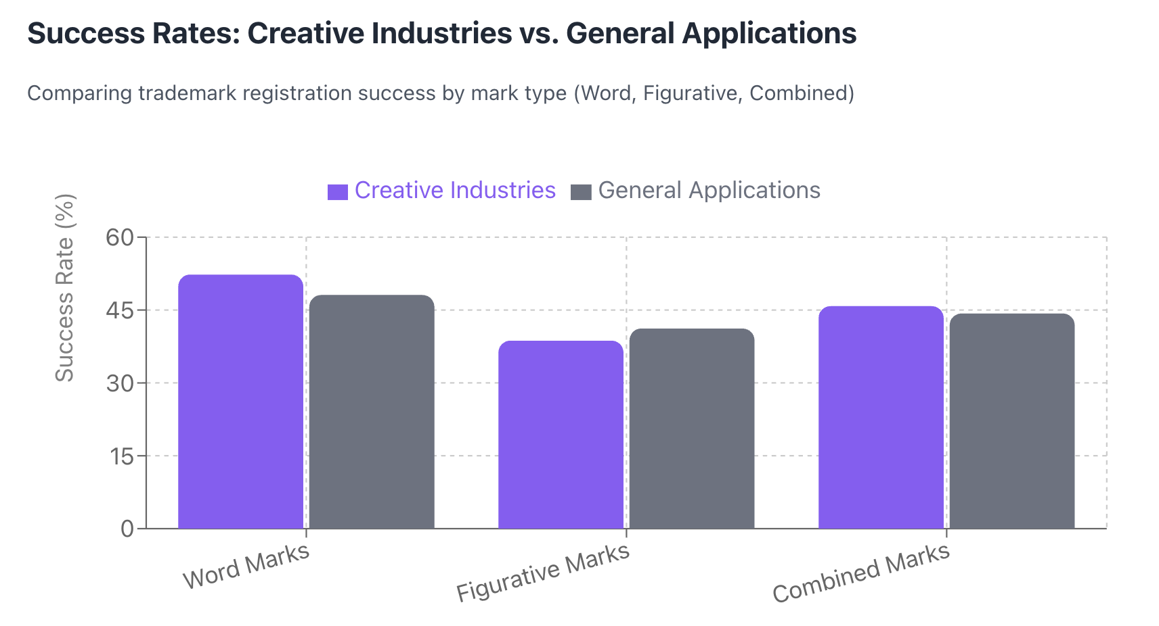
Figure presents the overall trademark application status distribution across the Canada Trademarks Dataset, revealing that only 44.6% of applications achieve registration while 49.3% experience failure through expungement or abandonment. This baseline establishes the magnitude of IP barriers YSSL's platform must address.
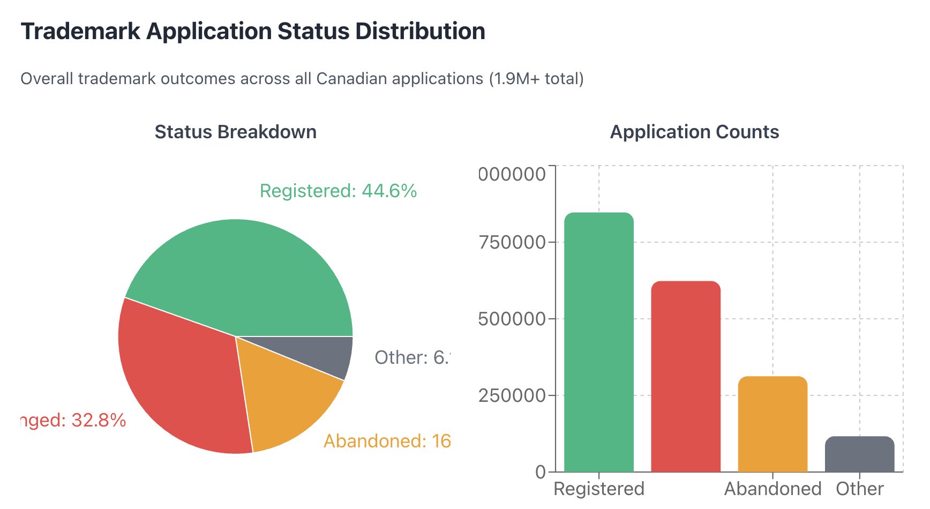
Figure demonstrates that creative industries experience differential success patterns across mark types, with Word marks achieving 52.3% success versus 38.7% for Figurative marks—a 13.6 percentage point gap. These findings directly inform YSSL's platform design: automated validation should flag when creative professionals select logo-based trademarks and recommend text-based alternatives when appropriate.
For Academic Contribution:
First systematic quantification of trademark registration disparities between creative and non-creative industries in Canada. Validation of machine learning applicability to administrative IP data for outcome prediction. Methodological framework replicable for analyzing other IP protection mechanisms (copyright, industrial design) facing creative professionals.
For Creative Sector:
Evidence-based documentation of systemic IP barriers facing Canadian artists, musicians, filmmakers, and designers, supporting policy advocacy for IP system reforms benefiting creative economy participants.

Implementation Timeline
Phase 1 - Data Acquisition and Preparation (Weeks 1-2):
Dataset download and initial exploration, creative industry identification algorithm development and validation, data cleaning protocols for missing values and inconsistencies, exploratory data analysis establishing baseline statistics.
Phase 2 - Descriptive Analytics (Weeks 2-3):
Success rate calculations across creative industries and subsectors, temporal trend analysis (2000-2023), comparative statistical testing (creative vs. baseline), processing timeline analysis, initial visualization development.
Phase 3 - Predictive Modeling (Weeks 4-5):
Feature engineering and dataset preparation for machine learning, baseline model development (Logistic Regression), ensemble method implementation (Random Forest, XGBoost), hyperparameter tuning and cross-validation, model performance evaluation and comparison.
Phase 4 - Insight Synthesis (Weeks 5-6):
Translation of analytical findings into platform recommendations, dashboard and visualization finalization, comprehensive report drafting integrating statistical results with strategic insights, presentation materials development.
Phase 5 - Validation and Documentation (Weeks 7-8):
Peer review of analytical methods and conclusions, code documentation and GitHub repository publication, final report editing and formatting, stakeholder presentation preparation.

Resources Required
Data Resources: Canada Trademarks Dataset (publicly available, no acquisition costs). Technical Resources: Python environment with standard data science libraries (freely available through Anaconda distribution), computational resources sufficient for processing 1.9M+ record dataset (standard laptop adequate with appropriate data sampling strategies if memory constraints arise). Reference Resources: Access to academic databases for IP law research supplementing literature review (available through Northeastern University library).

G. Conclusion
This analytical project addresses YSSL's strategic need for evidence-based understanding of intellectual property barriers facing Canadian creative professionals. By systematically analyzing 1.9+ million trademark applications spanning creative industries, the research quantifies registration success disparities, processing delays, and failure patterns that informal observation suggests but data has not yet validated.
The methodology combines rigorous descriptive analytics establishing baseline creative industry trademark performance with advanced predictive modeling enabling proactive risk identification. This dual approach ensures YSSL receives both strategic intelligence about which creative subsectors face greatest IP challenges and tactical tools for supporting individual users navigating trademark applications. The creative industry filtering algorithm, temporal analysis framework, and machine learning models are designed for adaptability—methodologies developed for trademark analysis extend to examining other IP protection mechanisms (copyright registration, industrial design protection) YSSL's platform may eventually address.
Implementation provides YSSL immediate value through platform feature prioritization guidance while establishing analytical foundations for ongoing data-driven decision making as their Creative ERP/CRM evolves. The project embodies YSSL's mission of empowering creative professionals through transparent, accessible systems by transforming opaque administrative IP data into clear insights illuminating paths toward successful brand protection.
Success extends beyond YSSL's operational improvements to advance broader creative sector advocacy. Documented evidence of systemic trademark barriers facing artists, musicians, filmmakers, and designers strengthens policy arguments for IP system reforms benefiting Canada's creative economy. The project demonstrates how data analytics transforms administrative records into strategic intelligence supporting both organizational excellence and sector-wide equity.
Annotated Bibliography
Sheff, J. N. (2021). The Canada Trademarks Dataset. Journal of Empirical Legal Studies, 18(4), 908-955. https://doi.org/10.1111/jels.12303
This article presents the Canada Trademarks Dataset as a comprehensive resource for empirical legal research on intellectual property systems. Sheff compiled individual-application-level data from the Canadian Intellectual Property Office covering 1.6+ million trademark applications from registry inception in 1865 through 2021. The dataset includes complete prosecution histories, bibliographic information, applicant details, and lifecycle status data enabling longitudinal analysis of registration outcomes. Sheff's analysis demonstrated that Canada's trademark registration system substantially underperforms peer nations regarding examination efficiency. Recent statutory changes potentially exacerbate processing delays while decreasing registry reliability. The research identified significant variation in registration timelines and success rates across application characteristics including mark type, applicant nationality, and goods/services classifications.
This foundational work provides both the primary data source and methodological blueprint for the current project analyzing creative industry trademark barriers. Sheff's demonstration that registration outcomes vary systematically by application characteristics validates this project's approach of examining creative industries as a distinct population requiring tailored analysis. His findings that Canada's trademark system exhibits efficiency challenges establish the context for investigating whether creative professionals face disproportionate barriers compared to general business applicants. The dataset's comprehensive coverage and individual-application granularity enable the precise filtering and comparative analysis this project requires to identify creative sector-specific patterns. Sheff's methodological emphasis on combining large-scale quantitative analysis with institutional context informs how this project will translate statistical findings into policy-relevant insights for Your Sweet Spot Life's platform design and broader creative sector advocacy.
Sheff, J. N. (2023). Canada Trademarks Dataset (Version 2.0) [Data set]. Zenodo. https://doi.org/10.5281/zenodo.7830123
This dataset represents the updated and expanded version of the Canada Trademarks Dataset, extending coverage through 2023 and incorporating improvements based on user feedback and data quality refinements. The dataset now includes 1.9+ million trademark application records with enhanced data fields and improved documentation. The CC-BY-4.0 licensing with additional CIPO terms enables academic research and commercial analysis while respecting intellectual property office requirements. The dataset provides researchers unprecedented access to comprehensive trademark registration data enabling empirical analysis of IP system performance, applicant behavior patterns, and registration outcome predictors across multiple decades.
This updated dataset serves as the primary data source for the current project's analysis of creative industry trademark barriers. The extended temporal coverage through 2023 enables analysis of recent trends and ensures findings reflect current IP registration landscape rather than historical patterns potentially no longer applicable. The expanded record count and enhanced data quality support more robust statistical analysis and machine learning model development. The dataset's public availability and clear licensing terms facilitate reproducible research and enable this project's findings to be validated by other researchers or extended in future work. For Your Sweet Spot Life's practical needs, using the most current available data ensures platform design recommendations reflect contemporary trademark registration challenges rather than outdated barriers potentially already addressed by system reforms. The comprehensive prosecution history data enables sophisticated analysis of where in the application lifecycle creative professionals encounter obstacles, informing where YSSL's compliance support features should focus intervention efforts.
World Intellectual Property Organization (WIPO). (2023). Guidelines on Intellectual Property for Creative Industries. Geneva: WIPO. https://www.wipo.int/publications/en/details.jsp?id=4652
This publication provides comprehensive guidance on intellectual property protection strategies specifically tailored to creative industry professionals including artists, musicians, filmmakers, designers, and digital content creators. The guidelines address common challenges creative professionals face in navigating trademark, copyright, industrial design, and patent systems. The document emphasizes that small creative enterprises often lack access to affordable legal expertise and face disproportionate barriers compared to established corporations with dedicated IP departments. WIPO identifies systematic obstacles including complex filing requirements, lengthy processing timelines, high application costs, and difficulty anticipating registration outcomes without legal training. The guidelines recommend that IP offices and support organizations develop accessible educational resources, simplified application processes, and proactive compliance assistance tools specifically designed for creative sector needs.
These findings provide policy context validating the practical importance of this project's analysis of trademark barriers facing Canadian creative professionals. WIPO's identification of systematic obstacles creative enterprises face when seeking IP protection establishes that the challenges Your Sweet Spot Life (YSSL) seeks to address through their Creative ERP/CRM platform reflect internationally recognized barriers rather than localized Canadian issues. The guidelines' emphasis on developing accessible compliance assistance tools directly aligns with this project's goal of translating trademark registration analysis into actionable platform features for Your Sweet Spot Life. WIPO's recommendation that support organizations provide proactive guidance helping creative professionals anticipate registration outcomes validates this project's predictive modeling approach. If machine learning models can forecast which trademark applications face high abandonment risk, YSSL's platform can operationalize WIPO's recommended proactive assistance by alerting users about problematic application characteristics before costly filing. The guidelines reinforce that quantifying creative industry IP barriers serves not only YSSL's immediate platform development needs but also contributes to broader creative sector advocacy by documenting obstacles warranting policy attention and system reforms.

REFERENCES
Sheff, J. N. (2021). The Canada Trademarks Dataset. Journal of Empirical Legal Studies, 18(4), 908-955. https://doi.org/10.1111/jels.12303
Sheff, J. N. (2023). Canada Trademarks Dataset (Version 2.0) [Data set]. Zenodo. https://doi.org/10.5281/zenodo.7830123
Susnjak, T., Ramaswami, G. S., & Mathrani, A. (2022). Learning analytics dashboard: A tool for providing actionable insights to learners. International Journal of Educational Technology in Higher Education, 19(1), 12. https://doi.org/10.1186/s41239-021-00313-7
Swan, P., & Atkinson, S. (2012). Managing evaluation: A community arts organization perspective. Arts & Health, 4(3), 217-229. https://doi.org/10.1080/17533015.2012.665372
Ucar, K., Jovanovic, M., & Vogiatzis, C. (2022). Analyzing and predicting success of professional musicians. Scientific Reports, 12, 19123. https://doi.org/10.1038/s41598-022-25430-9
World Intellectual Property Organization (WIPO). (2023). Guidelines on Intellectual Property for Creative Industries. Geneva: WIPO. https://www.wipo.int/publications/en/details.jsp?id=4652

